**DBMS LAB FILE**

**SQL**

* [SQL Create Table](https://www.w3schools.com/sql/sql_create_table.asp" \t "https://www.w3schools.com/sql/_top)

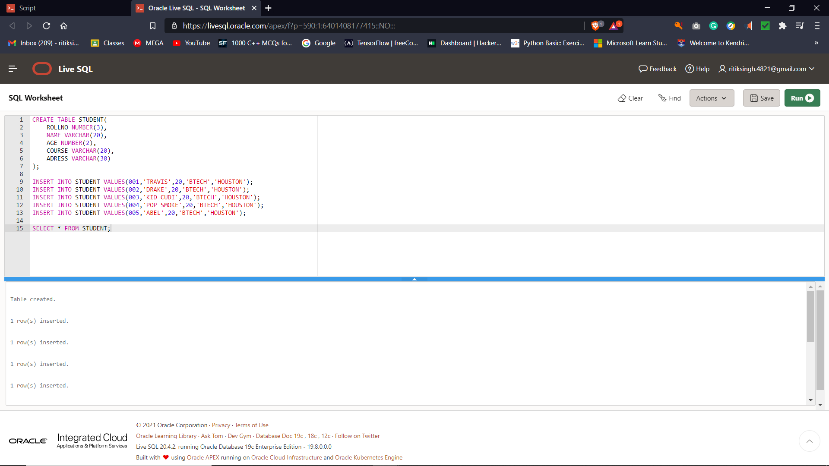

* [SQL Drop Table](https://www.w3schools.com/sql/sql_drop_table.asp" \t "https://www.w3schools.com/sql/_top)

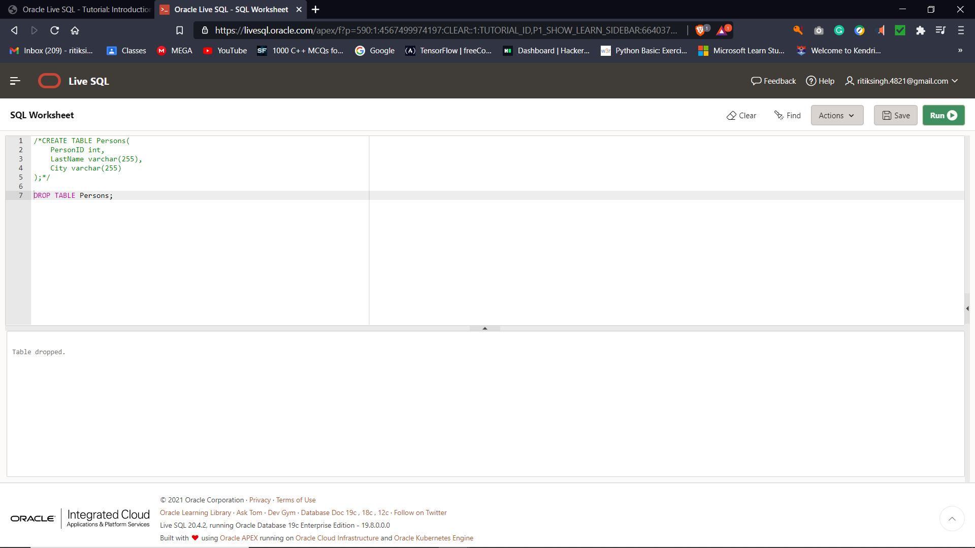

* [SQL I](https://www.w3schools.com/sql/sql_alter.asp" \t "https://www.w3schools.com/sql/_top)nsert



* [SQL Alter Table](https://www.w3schools.com/sql/sql_alter.asp" \t "https://www.w3schools.com/sql/_top)
* UPDATE

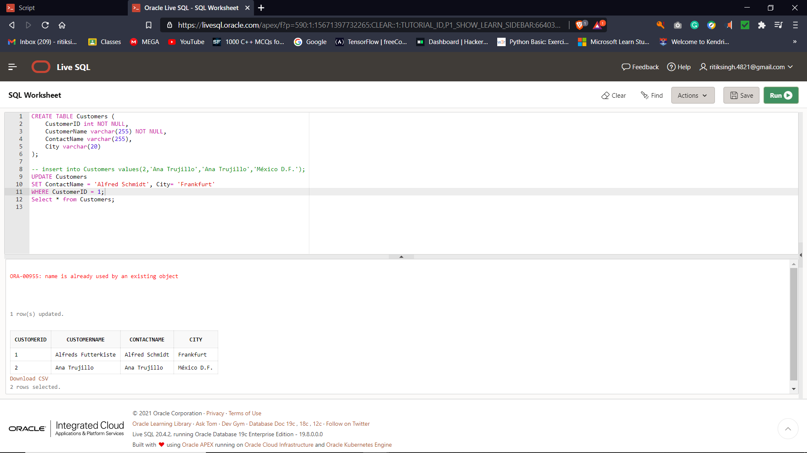

* [SQL Constraints](https://www.w3schools.com/sql/sql_constraints.asp" \t "https://www.w3schools.com/sql/_top)
* [SQL Not Null](https://www.w3schools.com/sql/sql_notnull.asp" \t "https://www.w3schools.com/sql/_top)
* 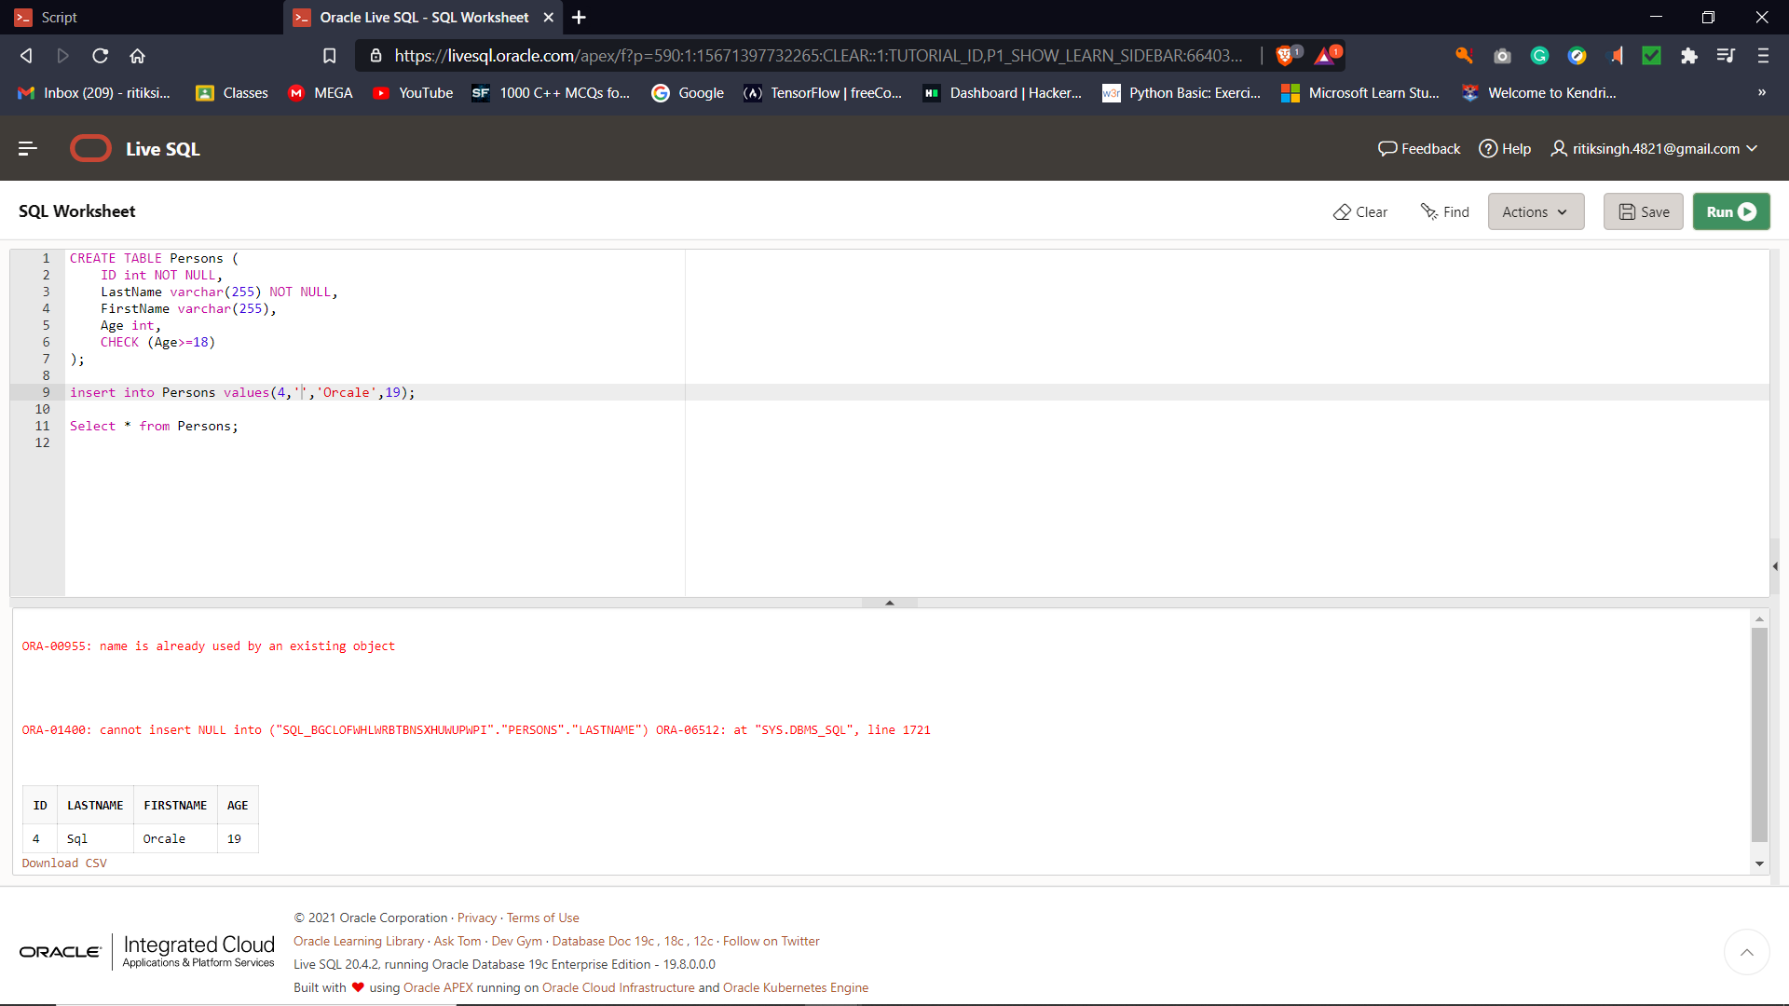
* [SQL Unique](https://www.w3schools.com/sql/sql_unique.asp" \t "https://www.w3schools.com/sql/_top)
* [SQL Primary Key](https://www.w3schools.com/sql/sql_primarykey.asp" \t "https://www.w3schools.com/sql/_top)
* [SQL Foreign Key](https://www.w3schools.com/sql/sql_foreignkey.asp" \t "https://www.w3schools.com/sql/_top)
* [SQL Check](https://www.w3schools.com/sql/sql_check.asp" \t "https://www.w3schools.com/sql/_top)
* [SQL Default](https://www.w3schools.com/sql/sql_default.asp" \t "https://www.w3schools.com/sql/_top)
* [SQL Index](https://www.w3schools.com/sql/sql_create_index.asp" \t "https://www.w3schools.com/sql/_top)

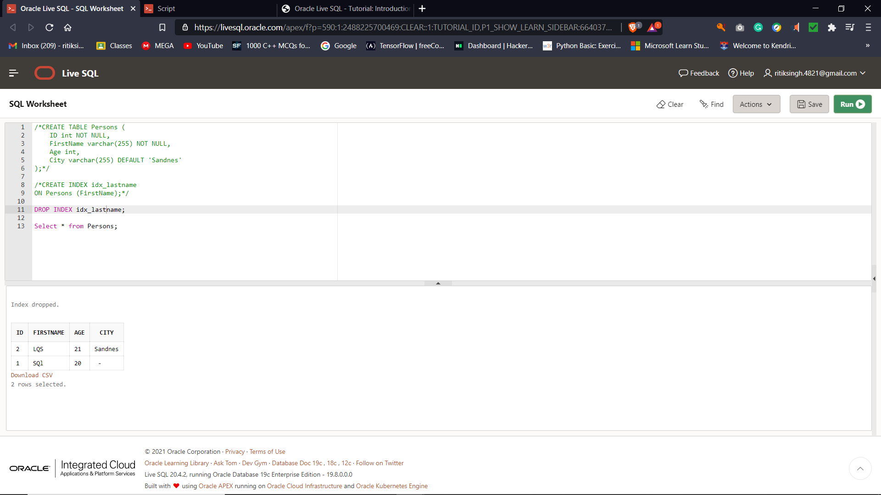

* [SQL Views](https://www.w3schools.com/sql/sql_view.asp" \t "https://www.w3schools.com/sql/_top)